DELETE Request

* localhost:3000/api/user/5

<https://www.prisma.io/docs/orm/overview/prisma-in-your-stack/rest>

**REST API server example**

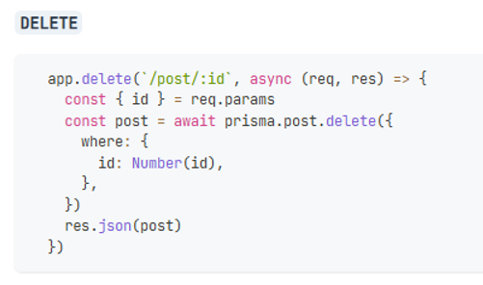

Server.js

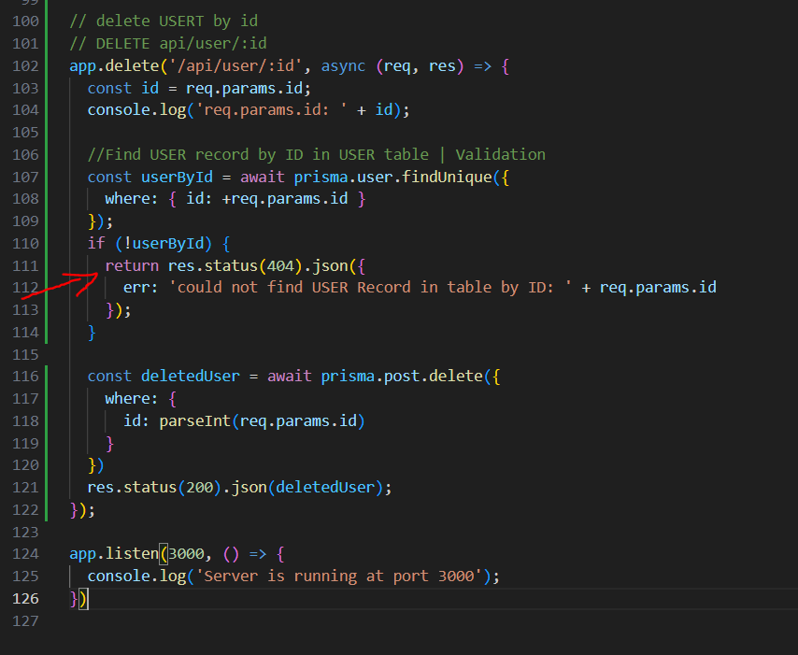

Server.js

// delete USERT by id

// DELETE api/user/:id

app.delete('/api/user/:id', async (req, res) => {

  const id = req.params.id;

  console.log('req.params.id: ' + id);

  //Find USER record by ID in USER table | Validation

  const userById = await prisma.user.findUnique({

    where: { id: +req.params.id }

  });

  if (!userById) {

    return res.status(404).json({

      err: 'could not find USER Record in table by ID: ' + req.params.id

    });

  }

  const deletedUser = await prisma.post.delete({

    where: {

      id: parseInt(req.params.id)

    }

  })

  res.status(200).json(deletedUser);

});

app.listen(3000, () => {

  console.log('Server is running at port 3000');

})

On package.json:

"dev": "nodemon --watch --exec node src/server.js",

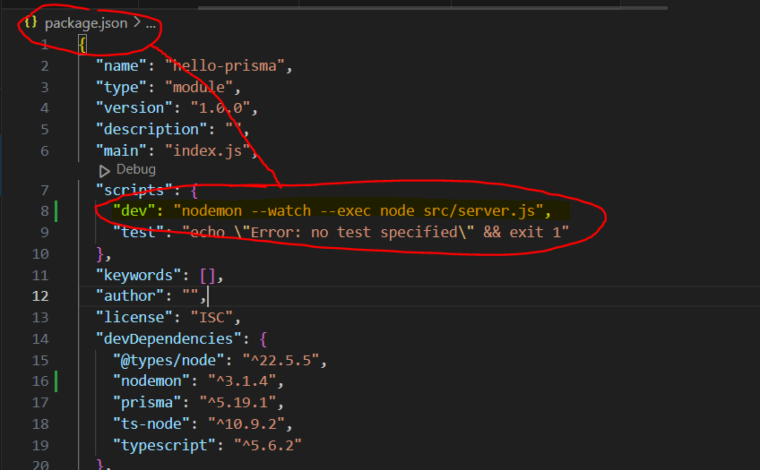

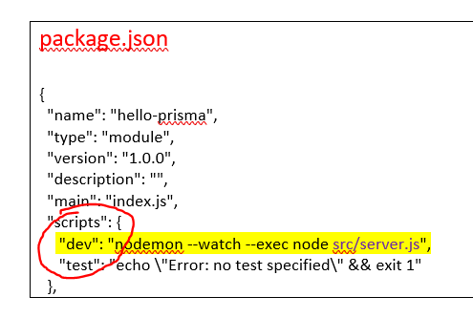

package.json

{

  "name": "hello-prisma",

  "type": "module",

  "version": "1.0.0",

  "description": "",

  "main": "index.js",

  "scripts": {

     "dev": "nodemon --watch --exec node src/server.js",

    "test": "echo \"Error: no test specified\" && exit 1"

  },

* RE-RUN SERVER…   
  (As long as change something in the server.js. We need to re-run the server.)
* Ctrl + C 🡪 Type 🡪 J 🡪 Stop the Server

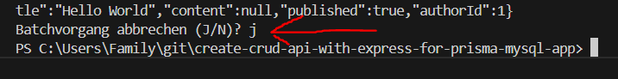

* RUN SERVER… | npm run dev

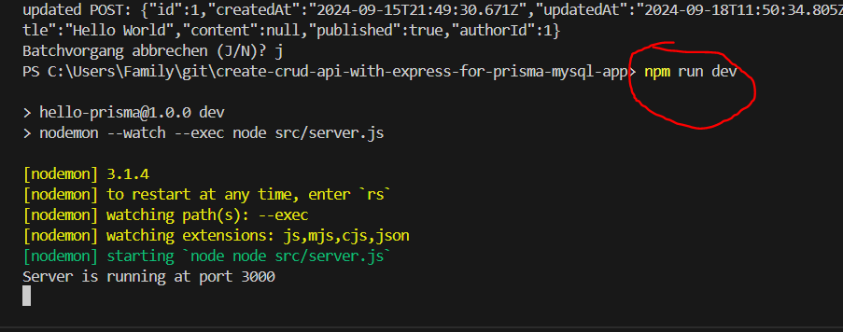

* Thnder Client | http Client

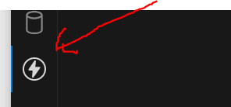

<https://www.prisma.io/docs/orm/overview/prisma-in-your-stack/rest>

**REST API server example**

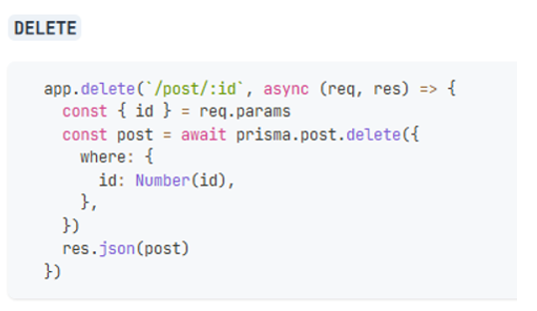 **MySQL database USER table without ID=91. Use for ERROR validation.**

**USER 🡪 ID=5**

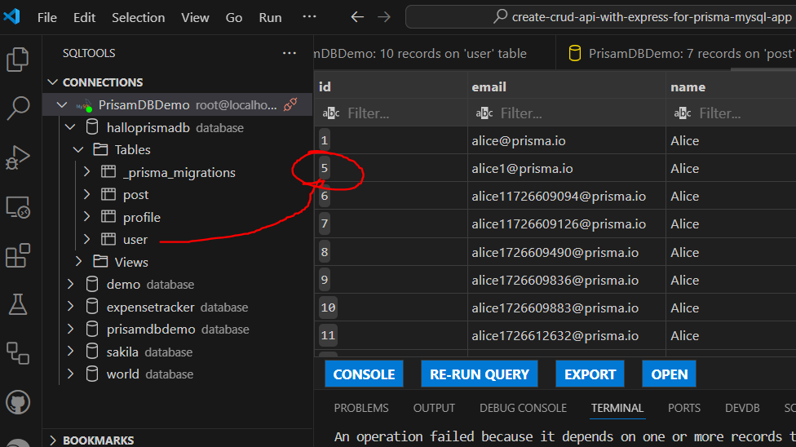

**PROFILE 🡪 ID=5**

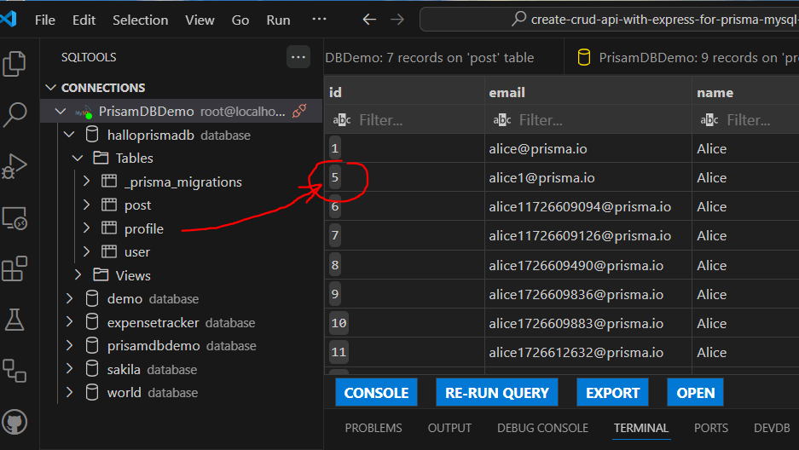

**POST 🡪 ID=5**

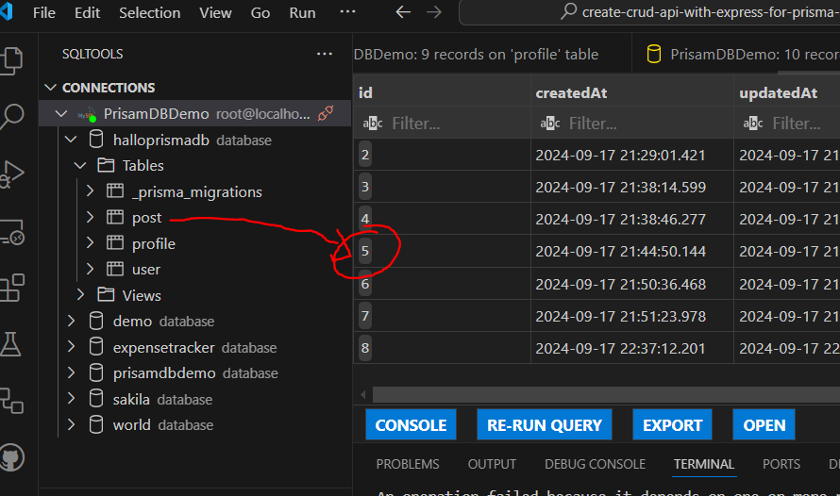

**ERROR Validation**

**DELETE 🡪 localhost:3000/api/user/91**

**:id = 91**

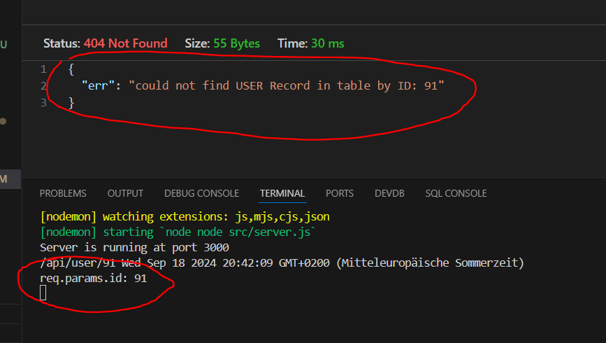

GET Response deleted error info with Status 404 Not Found OK 😊

{

"err": "could not find USER Record in table by ID: 91"

}

LOG 🡪

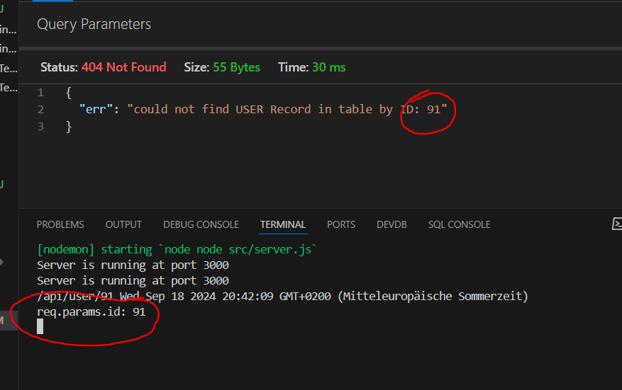

**DELETE USER with ID=5**

**DELETE 🡪 localhost:3000/api/user/5**

**:id = 5**

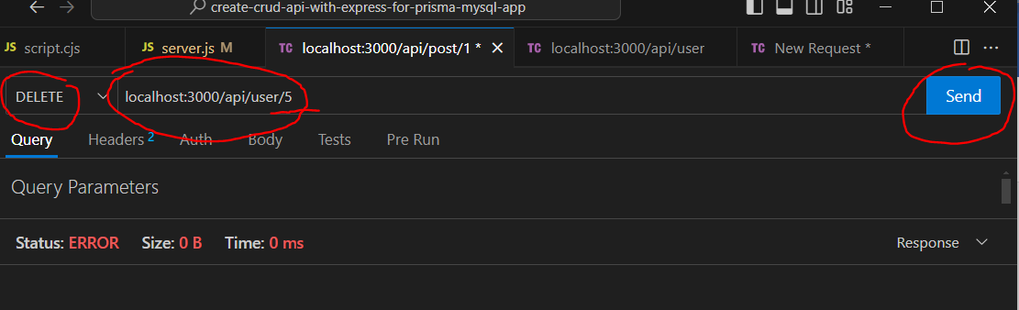

**USER, POST, PROFILE were delted successfully** 😊

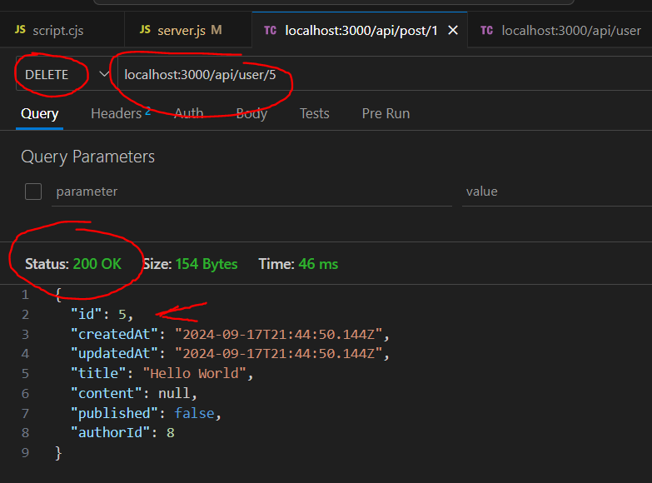

LOG 🡪

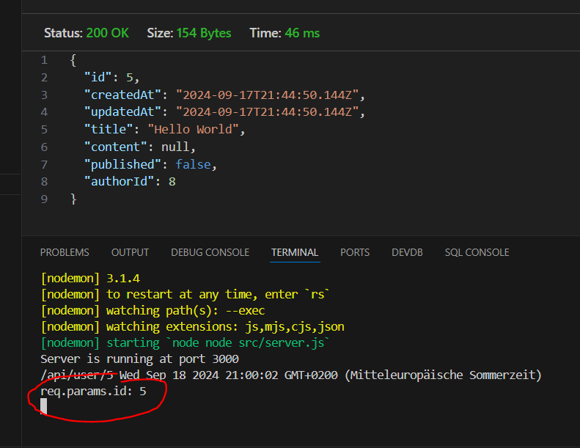

My SQL Database

POST ID=5 was deleted.

